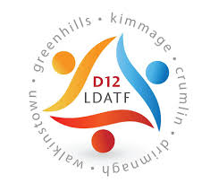

**Mapping and assessment of mental health, addiction and related services provided within the**

**Dublin 12 Local Drugs Taskforce Area**

**1. Introduction**

The purpose of this research is to create a greater knowledge of current mental health and addiction services and how they are accessed. In order to progress with strategically planning for treating people experiencing co-occurring disorders, it is necessary to utilise the information gathered, at both operational and strategic levels. This research will identify gaps at the service level and highlight what is required in terms of staff interaction, existing skills, development and training.

**2. Background**

In 2015, the HSE Mid-West region conducted a piece of research on an “Integrated Community, Recovery and Evidence Based Treatment Resource for Those Struggling with Co-Occurring Conditions”. In this study it was identified that the presentation of those suffering from co-occurring disorders (mental health and substance misuse) is prevalent and wider spread. Treatment for a dual-diagnosis of mental health and substance misuse is problematic. Common outcomes for patients suffering from a dual diagnosis include: “suicide and self-harm, higher rates of hospitalisation, longer duration of admission and increased risk of offending.” These can be identified as being a result of the separation of Mental Health and Addiction Services.

The results of the study showed that by providing a shared care model, in primary and secondary care, greatly improved access to treatment.

Despite strategic goals and action plans being outlined in, both the Connecting For Life Irelands Strategy for Action on Suicide Prevention 2015-2020 and the HSE Primary Care Division – Operational Plan 2015 on how to deal with dual diagnosis, little progress has been made in the Dublin 12 area.

**3. Methodology**

In order to complete this research that are three phases:

Firstly, **provide an accurate evidence base** for the purpose of reviewing, informing, identifying gaps and planning in mental health and addiction services in Dublin 12. An accurate evidence base is a complete, thorough and precise database of mental health services (statutory and non-statutory) within the study area. For more information on this section of the project please see Appendix 1.

Secondly, to **provide an overview and an assessment of the services.** The method of collating this information will be conducted through interviews. The interviews will be responsive to feedback received from HSE managers and local forums. Results of this will provide a thorough assessment of services that exist, identify service gaps and be an evidence base as to how they can strategically operate to benefit service users suffering from co-occurring disorders.

Thirdly, the evidence base developed from phase one and two, will be used to complete **set of recommendations with the LDTFA Co-Ordinator** to further the knowledge transfer strategically plan at an operational level how service-users can access both mental health and substance abuse services simultaneously.

**4. Interviews**

Interviews took place on the 9th and 10th of April in various locations in the Dublin 12 area. Interviews carried out were confidential. Each interview was assigned a number code to help ensure that personal identifiers are not revealed during the analysis and reporting of findings. It was possible for interviewees to opt out of the interview at any stage.

Topics covered in the interview included:

* Details of services provided
* Challenges services faced when service users have a dual-diagnosis
* What are the blocks and barriers that hinder service-users accessing these services in addition to other service?
* What are the gaps in the services?
* How can the services develop to cater for those suffering from a DD?

At this stage of the project it still has not been possible to interview service providers from the HSE Mental Health or Addiction Services. Efforts are on-going to secure an interview prior to the completion of the project.

**Interview Analysis:**

**4.1 Services provided**

As identified by the Addiction Service Providers, services provided were predominantly one on one sessions, however group and drop in sessions were also provided to service users. When accessing the service, service-users can access them with a self-referral and can be provided with an assessment within 72 hours. The service users benefitted greatly from individualised sessions. Group and drop in sessions provided service users with support and flexibility.

Mental Health Services are provided from the HSE and are made available through the Health Centres. Services include, Community Mental Health, Psychology, Day Centres and Day Hospitals. Waiting periods to access these services are dependent on demand of the services. In the case of emergencies those seeking Mental Health Services are urged to contact their GP or to attend A&E in Tallaght Hospital.

**4.2 Challenges services faced when service users have a dual-diagnosis**

Various challenges were identified by the Addiction Service providers in regards to service users that were suffering with a dual-diagnosis. First and foremost was that when a service user presented for addiction services it was possible for the Addiction Service providers to diagnose a substance misuse problem. It would be evident that some service users were also suffering from mental health issues, however they were still awaiting a diagnosis from the Mental Health Services. A factor in the delayed diagnosis from the Mental Health Services would be a result of lengthy waiting lists. Other challenges identified included:

* Lack of mental health diagnosis
* Unsuitable referrals to Addiction Services
* Lack of understanding of services provided within the addiction services
* Length of time taken to access Mental Health Services
* Lack of communication between agencies
* Lack of transfer of knowledge
* Mental Health services are governed by statutory agencies and addiction services by voluntary agencies

**4.3 Blocks and barriers that hinder service-users accessing Addiction Services in addition to other services?**

In regards to barriers which impede service users accessing Addiction Services in addition to other services, including Mental Health a number of common themes arose throughout the interview. These included a lack of interagency communication and involvement between Addiction and Mental Health Services. Those interviewed highlighted a consistent lack of interaction, consultation and protocol between the agencies. Other blacks and barriers included:

* Lack of interagency communication and involvement between agencies
* Lack of an integrated approach
* Lack of a clear route to access others agencies services
* Lack of involvement of other agencies at a service-user level
* Services are not integrated, the onus is on the service user themselves to access other services

**4.5 What are the gaps in the services?**

Interviewees were asked what gaps they felt were within their services provided when dealing with those suffering from a dual-diagnosis. A common gap identified was a lack of training in Mental Health and a lack of interagency communication. Other gaps identified included:

* Addiction services do not have adequate training
* Lack of interagency communication
* Lack of case management between agencies
* Lack of guidance in regards to mental health
* Lack of knowledge transfer
* Lack of access to statutory services

**4.6 How can the services develop to cater for those suffering from a DD?**

Finally, Addiction Service providers were asked how they felt services could develop to best provide for those suffering with a Dual-Diagnosis. The most common response from interviewees was a strengthened working relationship between both service providers. Areas that required the most strengthening were knowledge transfer and communication.

* The availability of Mental Health Services within the addiction services
* More training
* Interagency work
* Establishment of clear protocol between the agencies
* A memorandum of agreement between both agencies
* A transparent line of communication between the agencies#

**5. Next Steps**

Completion of analysis on interviews

Publication of final report and recommendations in conjunction with the Dublin 12 LDTF Co-ordinator

**Appendix 1**

**Addiction and Mental Health Services**



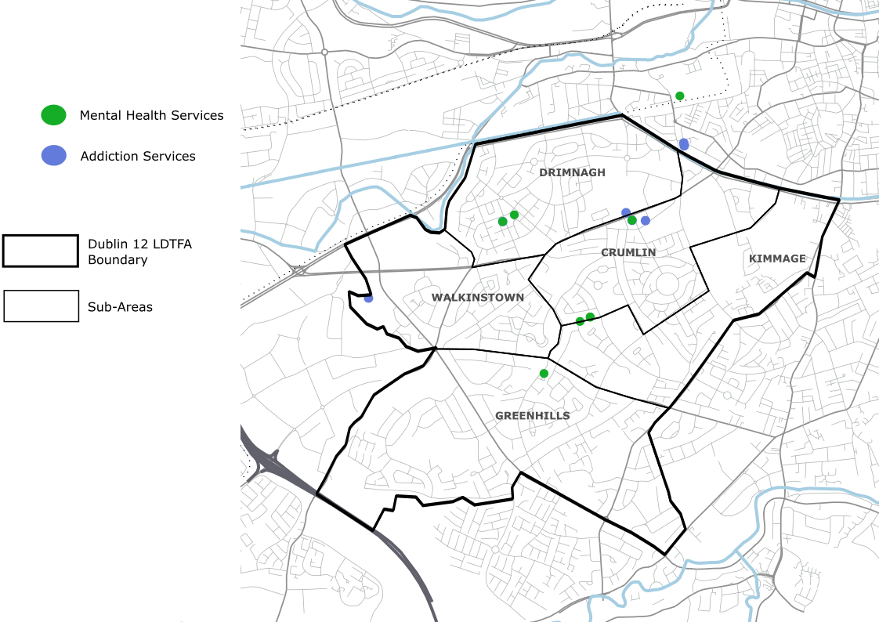

|  |  |
| --- | --- |
| **Service** | **Name** |
| Addiction | Walkinstown/Greenhills Resource Centre (WGRC) |
| Addiction | ARC/Lower Crumlin Family Support & An Fheileacain Family Support Service |
| Addiction | HSE Addiction Service - Crumlin |
| Addiction | HSE Addiction Services - Old County Road |
| Addiction | HSE Addiction Services - Curlew Road |
| Addiction | Rialto Community Drug Team |
| Addiction | Frontline Makes Change |
| Mental health Services | HSE Community Mental Health - Crumlin, Drimnagh Outpatient Department |
| Mental health Services | HSE Community Mental Health - Crumlin, Drimnagh |
| Mental health Services | GROW - Kimmage Support Group |
| Mental Health Services | HSE Psychology - Old County Road |
| Mental Health Services | HSE Psychology - Armagh Road |
| Mental Health Services | Mental Health - Armagh Road |
| Mental Health Services | HSE Mental Health - Curlew Road |
| Mental health Services | Jonathan Swift Clinic (James's Hospital) |